**Spectral Analysis of a random signal using Matlab**

**Lab # 05**



**Fall 2023**

**CSE-402L Digital Signal Processing Lab**

Submitted by: **Ali Asghar**

Registration No.: **21PWCSE2059**

Class Section: **C**

“On my honor, as student of University of Engineering and Technology, I have neither given nor received unauthorized assistance on this academic work.”

Submitted to:

**Dr. Yasir Saleem Afridi**

Date:

**27th November 2023**

**Department of Computer Systems Engineering**

**University of Engineering and Technology, Peshawar**

Lab No: 5.

## Title: Spectral Analysis of a random signal using Matlab

Provide .m file with detailed comments

Hint: Find Power Spectral Density,  a measurement of the energy at various frequencies,

Procedure:

1. First create some data. Consider data sampled at 1000 samples/sec. Start by forming a time axis for the data, running from t=0 until t=.25 in steps of 1 millisecond. Then form a signal, x, containing sine waves at 50 Hz and 120 Hz.

(Hint: x = sin(2*pi*50*t) + sin(2*pi*120*t);)

Code:

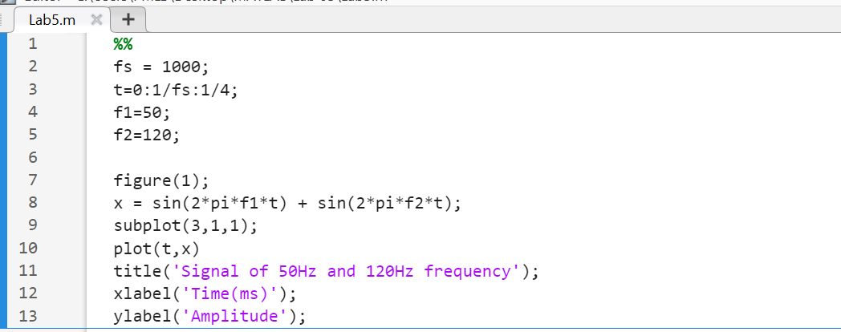

Output:

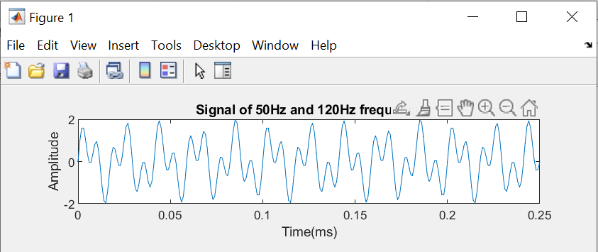

1. Add some random noise with a standard deviation of 2 to produce a noisy signal y. Take a look at this noisy signal y by plotting it. (Hint: y = x + randn(size(t));)

Code:

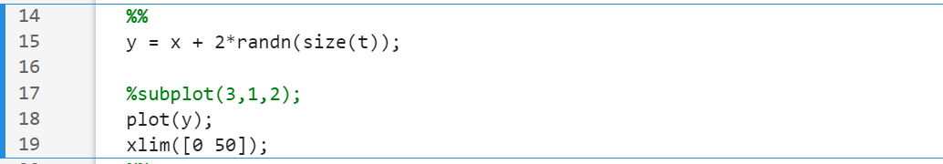

Output:

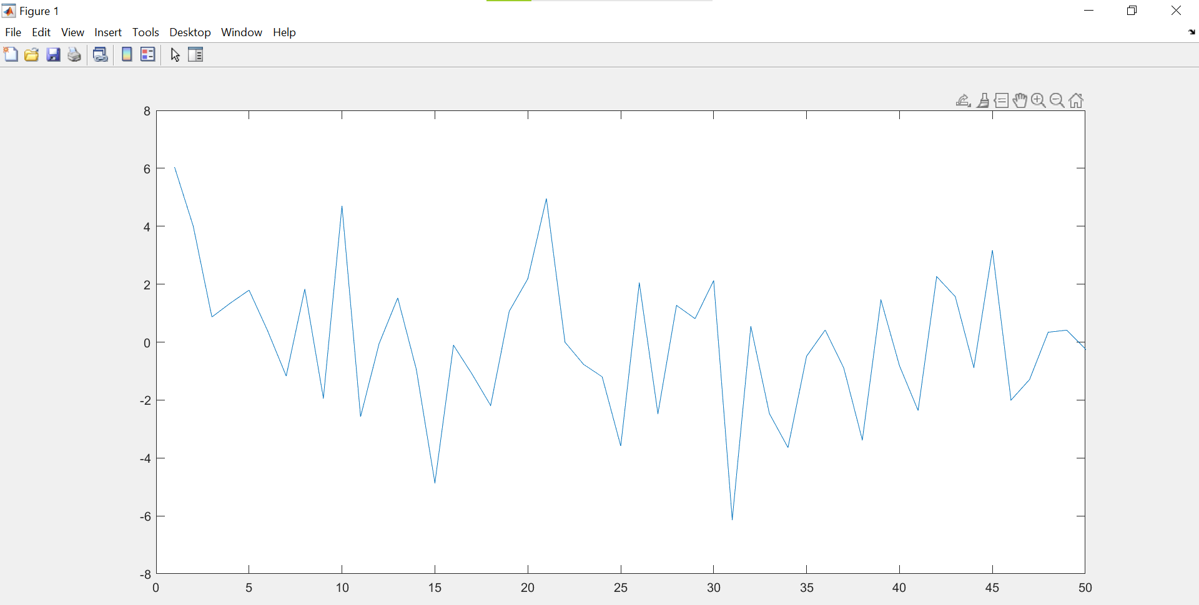

1. Finding the discrete Fourier transform of the noisy signal y (Hint: Y = fft(y,251);)

Code:

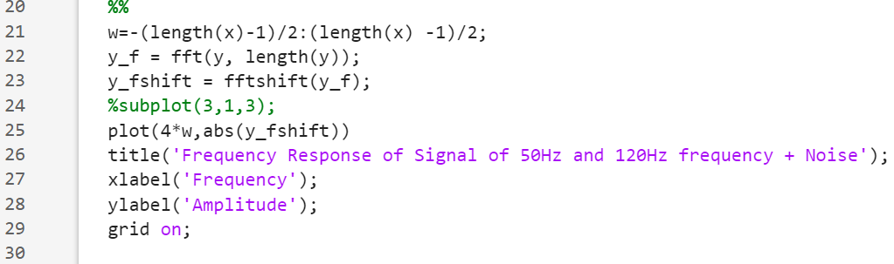

Output:

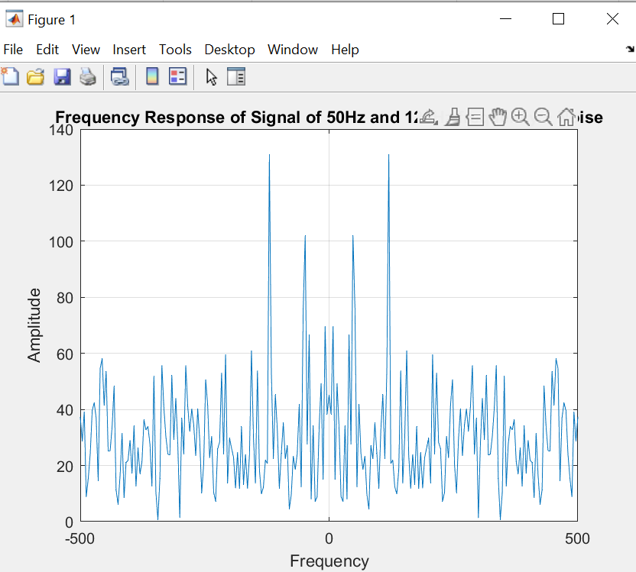

1. Compute the power spectral density, a measurement of the energy at various frequencies, using the complex conjugate (CONJ). Form a frequency axis for the first 127 points and use it to plot the result.  (Hint: Pyy = Y.*conj(Y)/251; f = 1000/251*(0:127);)

Code:

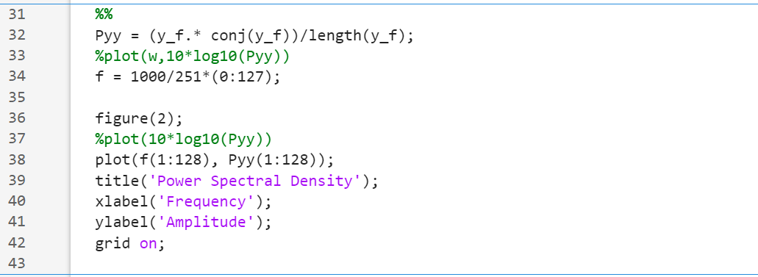

Output:

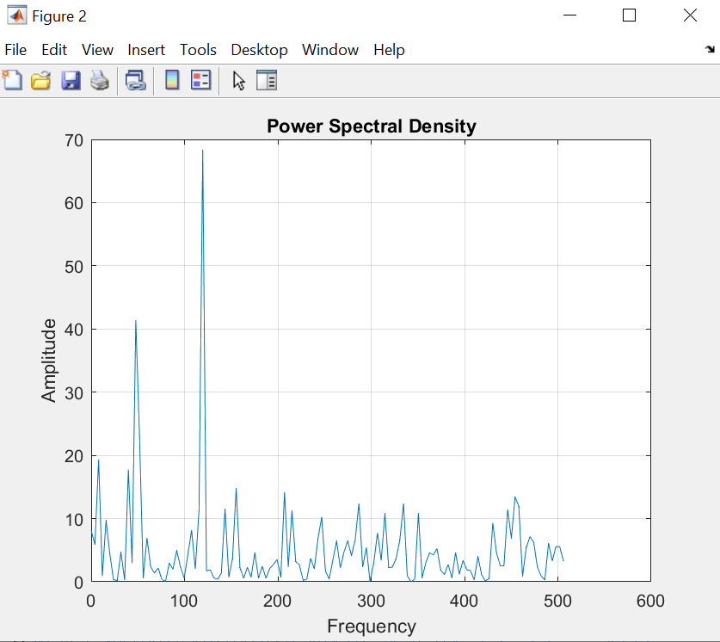

1. Compute and plot the periodogram using periodogram. Show that the two results are identical.

[Pyy2,w] = periodogram(y,rectwin(length(y)),length(y),1000)

figure;

plot(w,10*log10(Pyy2))

Code:

Output:

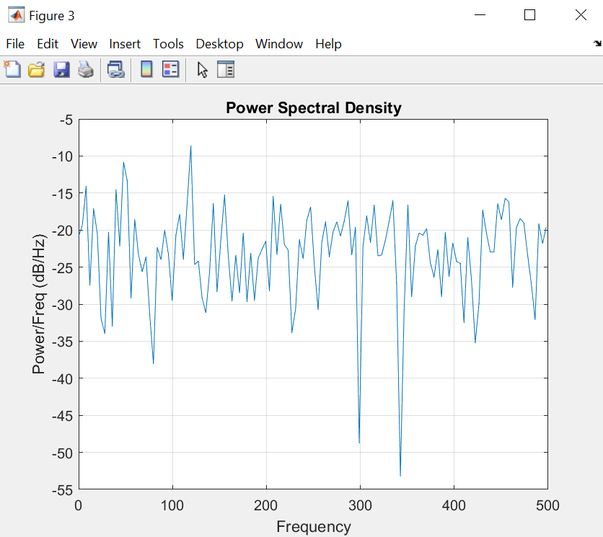

1. Zoom in and plot only up to 200 Hz. Notice the peaks at 50 Hz and 120 Hz. These are the frequencies of the original signal. ( Hint: plot(f(1:50),Pyy(1:50))

Code:



Output:

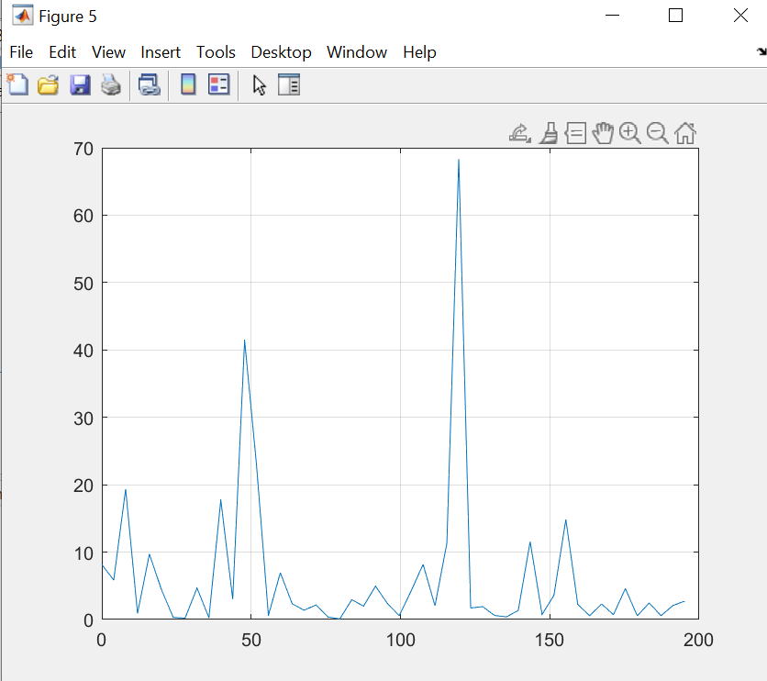

1. Final Remarks/Conclusion.

Full Code:

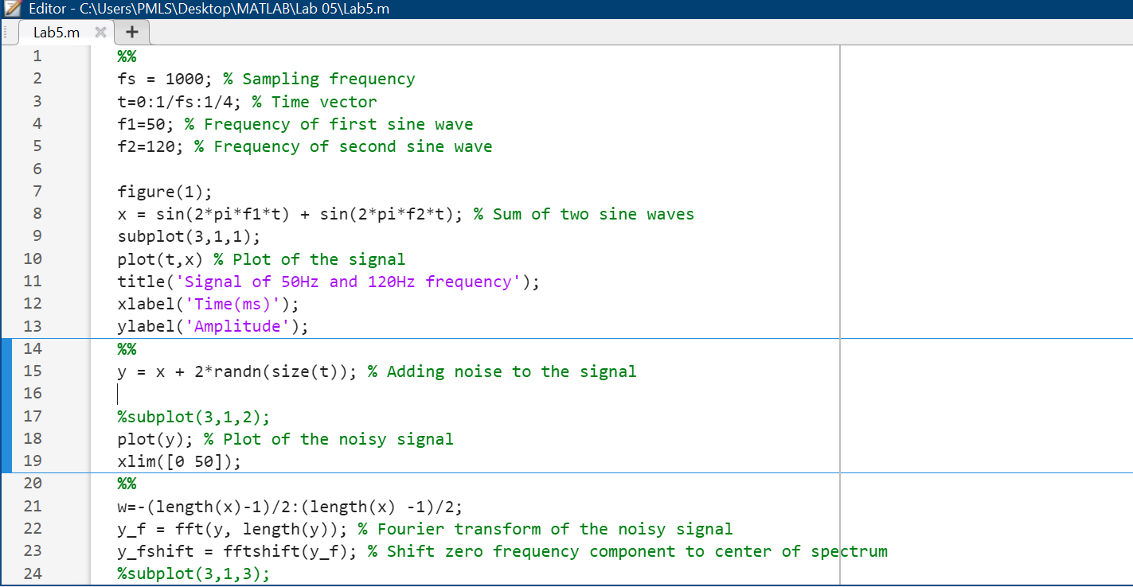

Remarks/Conclusion:

Initially, I created a random signal characterized by frequencies of 50Hz and 120Hz. Subsequently, random noise was introduced to the signal. Following the addition of noise, the signal was transformed into the frequency domain. The power density spectrum was then computed using the relevant formula. The next step involved plotting the periodogram of the power density signal, providing a visual representation of the signal's frequency components. To focus on specific frequencies of interest, a zoom-in was performed, honing in on the 50Hz and 120Hz components for closer examination.